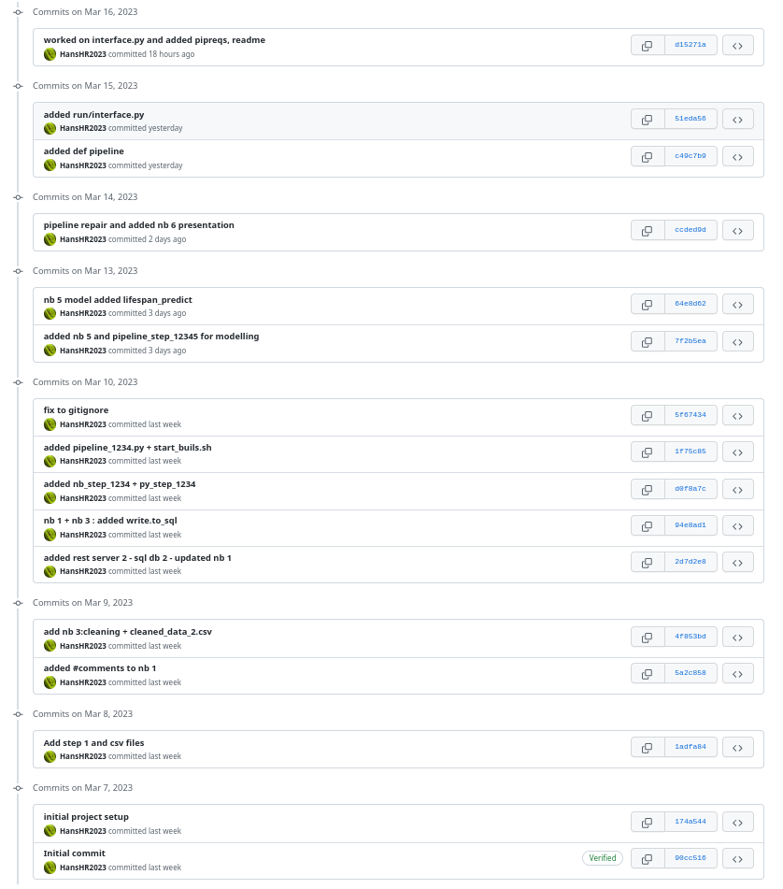
GIT historie Project p1 – Health Marketing

Hans Olthoff

De volledige historie kan hier worden ingezien:

https://github.com/HansHR2023/p1/commits/main

